**Estimating Hydrogen Storage Performance in Porous Rocks with Different Cushion Gases Using Reservoir Simulation and Deep Learning**

**Abstract**

**Introduction**

Why UHS?

Why UHS in porous rocks?

Why cushion gas in UHS?

Literature review of cushion gas studies in UHS

Limitations of current studies

Research gap

The approach of current study

The advantages of current study

The results of current study

The organization of the paper

**Methodology**

**Reservoir Simulation**

We perform 3D multiphase, compositional reservoir simulations for UHS operations in both saline aquifers and depleted gas reservoirs. The numerical simulator is tNavigator, and the simulations are run on the servers of Earth and Environmental Sciences Division at Los Alamos National Laboratory. This section describes the setup of the numerical simulations.

**Assumptions**

* The reservoirs are homogeneous, and the side boundaries are connected to an infinite water aquifer (outflow boundary conditions).
* The H2 is injected with the maximum allowable injection pressure and withdrawn with the minimum allowable production pressure.
* The gas dissolution into the aqueous phase is neglected due to its minimal impact on UHS performance.
* The H2 leakage through caprock is negligible so that the caprock is not included in the simulation domain.
* The salinity effect is neglected.

Simulation domain, properties, and conditions

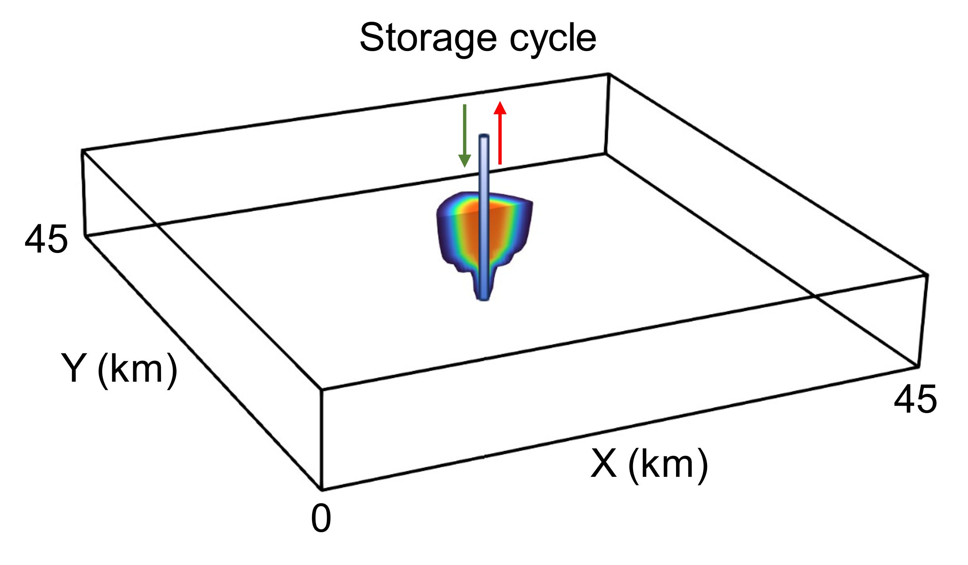

Figure-Schematic of simulation domain and well configuration. The well for gas injection and withdrawal is located at the center of the reservoir.

Fig. shows a representative simulation domain for both saline aquifers and depleted gas reservoirs. The areal dimensions of the domain are 45 km by 45 km, and the thickness varies from 10 to 300 m. The gas is injected and withdrawn through a central well. The computational mesh for the simulation domain is 151*151*10. The top and bottom boundaries of the simulation domain have a no-flow boundary condition. The side boundaries of the domain have an outflow boundary condition. Two sets of initial conditions are needed for two types of formations. For saline aquifers, the initial conditions include initial reservoir pressure and temperature. For depleted gas reservoirs, besides the initial reservoir pressure and temperature, we also need to set the initial water saturation which is a variable ranging from 0.2 to 0.9. Note that the depleted gas reservoir is assumed to have leftover/initial CH4, and the CH4 saturation is calculated based on the initial water saturation as Sch4=1-Sw. The initial reservoir pressure is calculated as hydrostatic pressure, and the initial temperature is calculated based on the reservoir depth and geothermal gradient, both of which are geologic variables in this study.

For all the simulations, we simulate 10 storage cycles. Each storage cycle lasts for one year, consisting of a 6-month injection stage and a 6-month withdrawal stage. As stated in the assumptions, we use a constant maximum allowable/sustainable injection pressure to inject H2 during the injection stage to ensure the maximum injection rate. The maximum allowable injection pressure  is calculated as follows.

 (1)

where  is the injection pressure coefficient, and the typical range is from 0.6 to 0.8 based on the previous literature ( ).  denotes a safety factor and has a value of 0.9.  is the lithostatic pressure determined by (Stauffer et al., 2008, Chen et al., 2020)

 (2)

Here,  is the atmospheric pressure (0.101325 MPa).  and  are the water density and rock density, respectively.  is the reservoir porosity, and  is the reservoir depth.

For withdrawal stages, we use the minimum allowable production pressure to retrieve the H2 at the highest rate. The production pressure  ranges from 3 to 6 MPa in this study to ensure that the fluid can be produced from reservoir to surface.

We also simulate the cases with cushion gas injection. Three typical cushion gases are considered, including CH4, N2, and CO2. The cushion gas is injected using the constant maximum allowable pressure before the H2. Cushion gas injection time is considered as another operational parameter, ranging from 2 to 12 months.

During the simulations, the spatial distributions of key properties and conditions such as reservoir pressure, H2 saturation, and cushion gas saturation, etc. can be obtained at each time step. Based on the simulation outputs, we define four important metrics to evaluate the UHS performance, including H2 withdrawal efficiency , produced H2 purity , produced gas-water ratio , and well injectivity . The  is the ratio of the recovered H2 volume to the injected H2 volume at each storage cycle. The Ph is essentially the H2 volume fraction (concentration) of the total produced gas stream. GWR is the ratio of the produced gas volume to the produced water volume.  measures the capability of injecting H2 into a geological formation and is calculated as

 (3)

where  is the injected H2 volume during one injection stage at a storage cycle.  is the H2 injection time, and it is 6-months in this study.  and  are the injection pressure and average reservoir pressure, respectively.

**ROM development**

We develop a unified ROM using DNNs based on the reservoir simulation data. The ROM inputs consists of geological and operational parameters, and the outputs are UHS metrics. The ROM can provide fast and accurate predictions for UHS operations in both saline aquifers and depleted gas reservoirs with different cushion gas scenarios.

Data preparation

To cover a wide range of scenarios that may be encountered at practical UHS sites, we use Latin Hypercube Sampling (LHS) () to generate the input parameters of the reservoir simulation. LHS ensures that samples span and fill the parameter space as effectively as possible so that the ROM is built with ample reservoir simulation data covering potential storage scenarios (Harp et al., 2016). Table.2 shows the ranges of geological and operational parameters for UHS simulations. The only difference between saline aquifers and depleted gas reservoirs is the initial water saturation Sw. The Sw equals 1 in saline aquifers, but it ranges from 0.2 to 0.9 in depleted gas reservoirs. In depleted gas reservoirs, the sum of the Sw and initial CH4 saturation is 1. Based on the parameters in Table.2, we can perform 8 types of reservoir simulations covering the UHS operations in both saline aquifers and depleted gas reservoirs with four cushion gas scenarios (no cushion gas, CH4, N2, and CO2). For each type of simulations, we generate 1000 combinations of uncertain parameters as simulation inputs. Totally, we perform 8000 reservoir simulations, each of which consists of 10 storage cycles. Each simulation provides predictions of the cyclic evolution of four UHS metrics.

Table.2-The ranges of geological and operational parameters for UHS simulations. The range of ‘cushion gas injection time’ only applies to cushion gas cases. For scenarios without cushion gas, the cushion gas injection time is 0.

|  |  |  |  |  |  |
| --- | --- | --- | --- | --- | --- |
| **Uncertain Parameters** | **Saline Aquifer** | | **Depleted Gas Reservoir** | | **Units** |
| **Lower Bound** | **Upper Bound** | **Lower Bound** | **Upper Bound** |
| Reservoir depth | 1000 | 3500 | 1000 | 3500 | m |
| Reservoir thickness | 10 | 300 | 10 | 300 | m |
| Permeability | 1 | 1000 | 1 | 1000 | mD |
| Porosity | 0.05 | 0.36 | 0.05 | 0.36 | / |
| Geothermal gradient | 0.015 | 0.045 | 0.015 | 0.045 | oC/m |
| Net-to-gross ratio | 0.4 | 1 | 0.4 | 1 | / |
| Injection pressure coefficient | 0.6 | 0.8 | 0.6 | 0.8 | / |
| Production pressure | 3 | 6 | 3 | 6 | MPa |
| Initial water saturation | 1 | 1 | 0.2 | 0.9 | / |
| Cushion gas injection time (Only for cushion gas cases) | 90 | 360 | 90 | 360 | Days |

DNN model

A unified reduced-order model …….

GPU

Data split

**Results and Analysis**

Figure-

1.For saline aquifers, the H2 withdrawal efficiency Eh has a slight negative correlation with the cushion gas injection time Tcg. The negative correlation between Ph and Tcg is much stronger than Eh and Tcg. Longer cushion gas injection greatly decreases the produced H2 purity. In contrast, GWR and CAP exhibit a positive correlation with Tcg, especially for GWR. More cushion gas injection can noticeably mitigate the risk of water production during the H2 withdrawal process. Also, injecting more cushion gas can expand the H2 storage capacity at each storage cycle.

2. For saline aquifers

1. Geologic parameters significantly impact the UHS performance. The dominant geologic parameters affecting UHS performance in both saline aquifers and depleted gas reservoirs include reservoir depth D, thickness H, and permeability K. For both formations, the H2 withdrawal efficiency Eh is positively correlated with D and K but negatively correlated with H. The produced H2 purity Ph of both reservoirs is negatively correlated with D, except for the case of CO2 cushion gas in saline aquifers. The produced gas-water ratio is positively correlated with D for both formations. In depleted gas reservoirs, GWR is strongly negatively correlated with initial water saturation Sw. In saline aquifers, since Sw is constant (1.0), the correlation coefficients are not calculated. The H2 storage capacity CAP shows very strong positive correlation with D, H, and K for both formations.
2. Operational parameters also have a huge impact on UHS performance.
3. The effect of cushion gases
4. In terms of produced H2 purity Ph, the correlation matrices of two formation are slightly different. In depleted gas reservoirs, the Ph exhibits a stronger negative correlation with D than saline aquifers.

The impact of geologic parameters

Saline aquifers

Depleted gas reservoirs

The impact of operational parameters

Saline aquifers

Depleted gas reservoirs

Figure-Cyclic evolution of the spatial distribution of H2 saturation for UHS operations in two formations (saline aquifers and depleted gas reservoirs) with different cushion gas conditions (no cushion gas, CH4, N2, and CO2).

A few observations form Fig.;

1. The H2 plume gradually grows over storage cycles. During the injection stages, the H2 plume has a high concentration, especially near the wellbore region (injection point). The H2 saturation decreases drastically during the withdrawal stage due to the retrieval of H2. However, the H2 footprint or the plume size remains almost the same during the withdrawal process, indicating that some of the H2 is trapped in the reservoirs. The amount of the trapped H2 increases over cycles.
2. The H2 plume shape in saline aquifers are distinctly different from the H2 plume shape in depleted gas reservoirs. Since the gas density is much smaller than the water, most of the H2 plume floats at the top of the reservoir due to buoyancy. In contrast, the H2 plume in depleted gas reservoirs are well mixed with the left-over CH4 and migrate deeper in the reservoirs. Besides, the H2 plume in depleted gas reservoirs is much larger than that of saline aquifers, indicating a higher storage capacity and well injectivity.
3. Cushion gas affects the H2 saturation distribution, but the impact is insignificant. At the first cycle of UHS in saline aquifers, we can observe that the case without cushion gas has a higher H2 saturation than cases with cushion gases. The cushion gas injection promotes the vertical migration of H2 plume as the cushion gas displaces water further away from the top of reservoirs. Cushion gas also affects the lateral migration of H2 plume. With CO2 as a cushion gas, the lateral spreading of H2 plume is mitigated due to the low mobility of CO2. As storage cycle advances, the impact of cushion gradually decreases. For UHS in depleted gas reservoirs, no noticeable impact from cushion gas is observed across all cycles.

Figure-Cyclic evolution of the spatial distribution of cushion gas (CH4, N2, and CO2) saturation for UHS operations in saline aquifers and depleted gas reservoirs.

A few observations from Fig,:

1. Under the same injection condition, saline aquifer receives much less cushion gas than depleted gas reservoirs due to its lower well injectivity. The cushion gas in saline aquifers floats at the top of the formations due to buoyancy. For depleted gas reservoirs, the cushion gas plume has a much larger thickness than saline aquifers because the cushion gas densities are equal or larger than the initial CH4.
2. In both formations, the cushion gas saturation gradually decreases as the storage cycle advances, and the cushion gas plume migrates further from the wellbore. The cushion gas is initially concentrated in the vicinity of the wellbore. Once the storage cycle starts, the cushion gas is pushed away from the wellbore by the injected H2 during the injection stage. During the withdrawal stages, the cushion gas plume contracts slightly, and some of the cushion gases is produced out. As the cycle increases, the cushion gas is better mixed with the initial CH4 or H2, leading to a lower saturation.
3. Different cushion gases have a noticeable difference in the cushion gas plume evolution. Due to a large density, the CO2 plume migrates deeper in the vertical direction than CH4 and N2. Besides density, the mobility of cushion gas also affects the plume migration. CH4 has the largest plume size due to its highest mobility among three cushion gases. The high mobility also makes CH4 easy to withdraw during the withdrawal stages. CO2 has the lowest mobility due to its large density and high viscosity (Zhao et al). Therefore, the CO2 plume has the smallest size and stays closest to the wellbore.

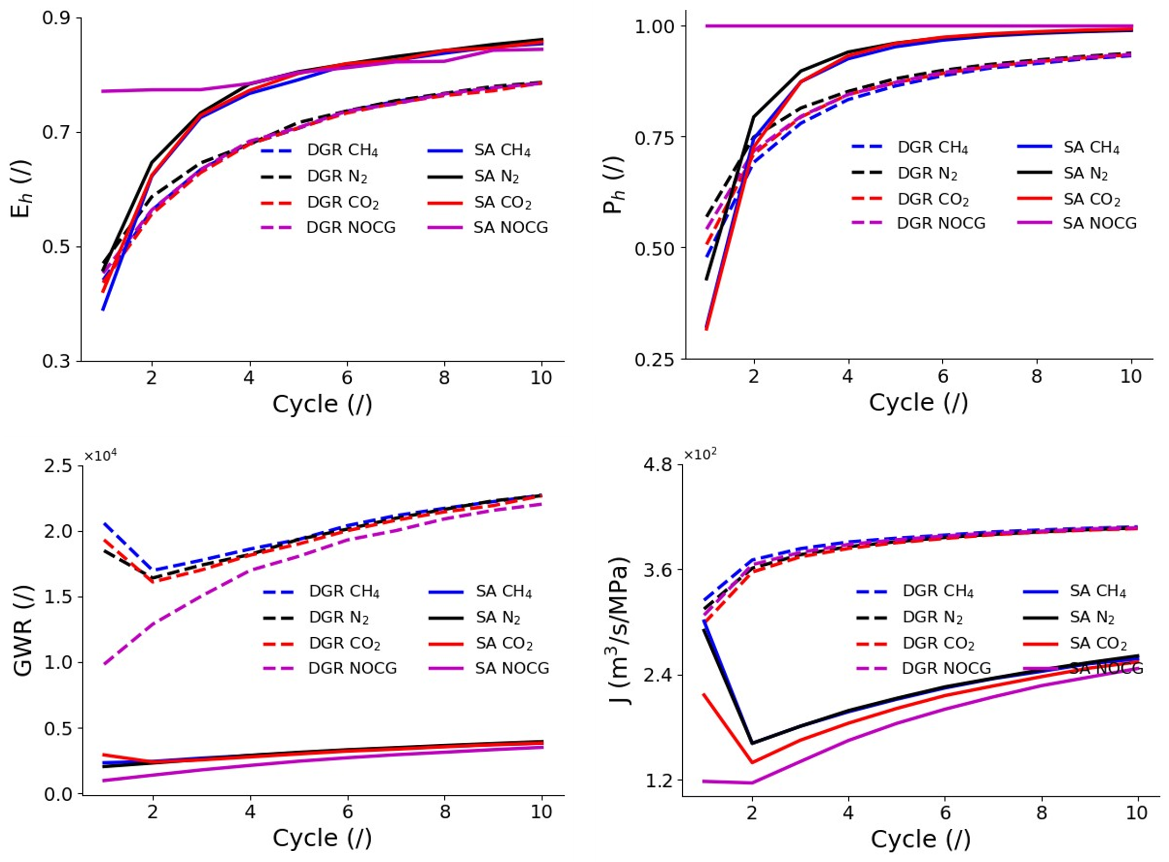Figure-Cyclic evolution of UHS performance metrics for base cases. (a) H2 withdrawal efficiency (Eh), (b) produced H2 purity (Ph), (c) produced gas-water ratio (GWR), and (d) Well injectivity (J).

A few observations:

1. Saline aquifers have a much higher Eh and Ph than depleted gas reservoirs, but with a much lower GWR and J. Without cushion gases, the UHS performance in both formations gradually improves as storage cycle advances.
2. In general, cushion gas injection has a much stronger impact on the UHS performance in saline aquifers than depleted gas reservoirs. The impact of cushion gas mainly occurs in early cycles and diminishes as the cycle increases.
3. The cushion gas injection in saline aquifers significantly reduces the Eh and Ph in early cycles. As cycle advances, the Eh and Ph gradually increases. The Eh of cushion gas cases in saline aquifers even exceeds the Eh of the SA NOCG case after the 6th storage cycle. Besides, the cushion gas drastically mitigates the risks of water production and improve the well injectivity in saline aquifers.
4. The cushion gas injection in depleted gas reservoirs does not have a huge impact on the Eh, Ph, and J. However, the cushion gas in depleted gas reservoirs increases the GWR significantly, especially in the early cycles.
5. For both saline aquifers and depleted gas reservoirs, the difference between the impact of cushion gas type is insignificant. N2 seems to be a good candidate for cushion gas in both formations because it achieves relatively higher Eh, Ph compared to CH4 and CO2, as well as its good capability to 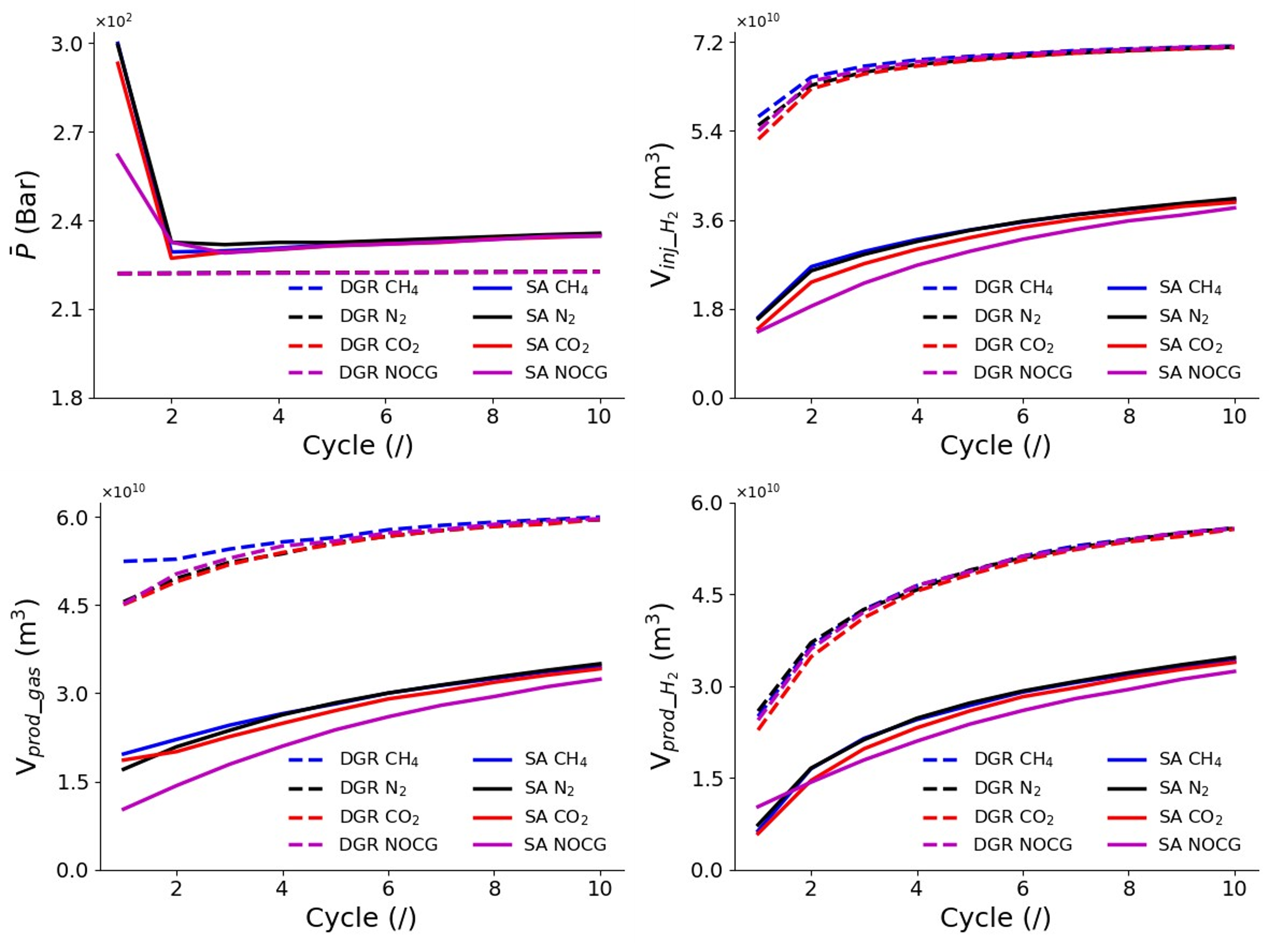mitigate the water production risks and improve the well injectivity.

Figure-

Fig provides some insights to understand the UHS performance in base cases.

1. The reservoir pressure buildup in saline aquifers is much higher than depleted gas reservoirs (Fig.a) due to a much lower compressibility of water than gases. The higher compressibility of gases also leads to a better well injectivity of UHS in depleted gas reservoirs. In saline aquifers, the injected cushion gas can displace some water away from the wellbore, thus improving the well injectivity (Fig.d). Note that the average reservoir pressure P_bar in depleted gas reservoirs almost remains the same due to three reasons: (a) the reservoir is large, and the pressure disturbance of UHS operations only occurs in a relatively small region, (b) the gas is highly compressible, and (c) the reservoir is open so the pressure variation can be mitigated through the fluid outflow or recharge through open boundaries.
2. The injected H2 amount Vinj_H2 in depleted gas reservoirs is much higher than saline aquifers (Fig. b) due to the better well injectivity for H2 injection in depleted gas reservoirs. Based on the observation of Figs. d and b. The Vinj_H2 is directly related to the well injectivity J. Since depleted gas reservoirs already have a good injectivity J, the cushion gas does not improve J significantly, and the CO2 and N2 can even lower the J due to their lower mobility than CH4. In contrast, the cushion gases can noticeably improve the J in saline aquifers as discussed previously, thus leading to a higher Vinj_H2.
3. The cushion gas injection affects the total amount of the produced gas Vprod_gas for both formations. For depleted gas reservoirs, the case with CH4 as a cushion gas has the highest Vprod_gas, and the other three scenarios achieve almost the same Vprod_gas. For saline aquifers, the cases with cushion gases produce much larger amounts of gases throughout the cycles. The difference between cases with different cushion gases is not significant. The increase of Vprod_gas leads to a higher produced gas-water ratio GWR, thus mitigating the risk of water production (Fig.c).
4. The cushion gas injection has a minor impact on the produced H2 amount Vprod_H2 in depleted gas reservoirs. The Vprod_H2 of four cases in depleted gas reservoirs is similar, and the cushion gas case with CO2 has a slightly lower Vprod_H2 than other three cases. An interesting observation is that even though the Vprod_gas increases noticeably at early cycles in the DGR CH4 case, the Vprod_h2 is almost the same as the case without cushion gas. This observation indicates that the produced gas has a high percentage of initial CH4 and cushion gas CH4, which results in a low produced H2 purity Ph (Fig. b).
5. The cushion gas injection noticeably impacts the Vprod_H2 in saline aquifers. The cushion gas injection lowers the Vprod_H2 at early cycles, but the Vprod_H2 increases as the cycle advances. The Vprod_H2 of cushion gas cases exceeds the case without cushion gas after the second storage cycle. The initial drop of Vprod_H2 in cushion gas cases indicates that large volumes of cushion gases are produced at early cycles, which can significantly reduce the H2 withdrawal efficiency Eh and produced H2 purity Ph at early times (Fig a and b).

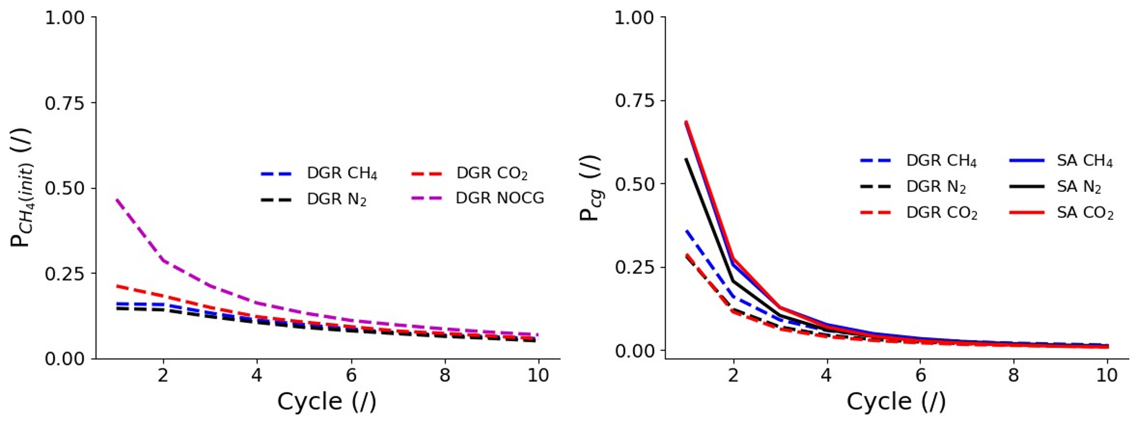

Figure-Cyclic evolution of the volume fraction of initial/left-over CH4 (a) and cushion gases (b) in the total produced gas. The sum of Ph, Pch4(init), and Pcg equals 1. For better visualization, the cushion gas CH4 is set as a different component from the initial CH4 in the DGR CH4 case, but they have the same properties.

To quantitatively analyze the composition of the produced gas, we plot the cyclic evolution of the volume fraction of initial/left-over CH4 (Pch4(init)) and cushion gases (Pcg) in the total produced gas (Fig. ). Fig.a shows the evolution of Pch4(init) in depleted gas reservoirs (saline aquifers do not have initial CH4). Fig. b shows the evolution of Pcg in cushion gas cases. Review of Fig. gives the following observations.

1. The Pch4(init) in depleted reservoirs gradually decreases as the storage cycle advances. As shown in Fig., the H2 plume gradually grows with increasing cycles, pushing the initial CH4 far away from the wellbore. Therefore, less initial CH4 is produced during late cycles.
2. Cushion gas can mitigate the production of initial CH4 during the withdrawal stages in depleted gas reservoirs. The Pch4(init) of the cushion gas is more than 50% lower than the DGR NOCG case (Fig. a). Among all the cushion gases, N2 has the best performance in lowering the initial CH4 production.
3. The Pcg in cushion gases cases declines with increasing cycles. There are two reasons for the delince of Pcg with cycles: (a) The cushion gas amount is limited, and most cushion gas is produced at early cycles. (b) As the storage cycle advances, the cushion gas is pushed further from the wellbore by the growing H2 plume (Fig.).
4. Saline aquifers have a higher Pcg than depleted gas reservoirs, indicating that the cushion gas is easier to be produced in saline aquifers than depleted gas reservoirs. This is reasonable because the cushion gas migrates much further from the wellbore in depleted gas reservoirs than saline aquifers (Fig. ). It is much easier to produce the cushion gas concentrated near the wellbore in saline aquifers. The significant cushion gas production in saline aquifers lead to a lower Eh and Ph at early cycles (Fig a and b). For both formations, CH4 have a large Pcg due to its good mobility. N2 is a good option for cushion gas because it has a low Pcg and Pch4(init).

**Reduced-Order Model**

**ROM Performance**

R2 figures

Figure-ROM performance on the training, validation, and test datasets in terms of predicting Eh (a, b, and c), Ph (d, e, and f), GWR (g, h, and i), and J (j, k, and l). Each figure shows the R2 score and average relative error .

Figure-Evolution of the training and validation loss over epochs.

Training and validation loss

Efficiency

**Uncertainty quantification**

Figure-Uncertainty quantification of UHS performance prediction in saline aquifers under four cushion gas scenarios: no cushion gas (a, e, i and m), CH4 (b, f, j and n), N2 (c, g, k, and o), CO2 (d, h, l and p). The blue line represents the mean value of the prediction, and the grey area is the prediction interval from P10 to P90. The U is the average uncertainty in the prediction across all the cycles.

Figure- Uncertainty quantification of UHS performance prediction in depleted gas reservoirs under four cushion gas scenarios: no cushion gas (a, e, i and m), CH4 (b, f, j and n), N2 (c, g, k, and o), CO2 (d, h, l and p).

We perform a comprehensive uncertainty quantification for UHS performance predictions using the efficient ROM by varying all the inputs over the entire parameter space. We conduct the uncertainty quantification based on two types of formations and four cushion gas scenarios (Figs. and ). For each type of storage formations, we use the ROM to make predictions on 35328 generated realizations per cycle. In Figs. and , the blue line illustrates the cyclic evolution of the prediction mean, and the grey area encompasses the prediction intervals defined by P10 and P90 values. P10 corresponds to the result at the 10% point on the cumulative distribution function, whereas P90 is at the 90% point. Besides, we also calculate the average uncertainty () as

, (4)

, (5)

where Ui is the uncertainty of the prediction at the ith storage cycle. n is the maximum cycle number (n=10). The findings from the uncertainty quantification can be divided into two categories.

The impact of storage formations on UHS performance

* Saline aquifers have a higher H2 withdrawal efficiency Eh than depleted gas reservoirs (Figs. 8a to d, Figs.9a to 9d), which is consistent with the base case observation (Fig. ). The H2 plume has a much larger footprint in depleted gas reservoirs than saline aquifer (Fig.), making the H2 more difficult to recover. The uncertainty of the UHS predictions in both formations are similar.
* Saline aquifers have a higher produced H2 purity Ph than depleted gas reservoirs (Figs.8e to f, Figs.9e to f). Without cushion gases, the Ph in saline aquifers is about 1.0 across the storage cycles. When the cushion gas is injected, the Ph in saline aquifers drops significantly at early cycles. However, the purity increases fast as the cycle advances and recovers back to the high level after 6 cycles. Since depleted gas reservoirs have large volumes of initial/left-over CH4, the H2 is always produced with other gas components, leading to a lower Ph. Besides, the depleted gas reservoirs also have a higher uncertainty in the Ph prediction than saline aquifers.
* Depleted gas reservoirs have a much higher produced gas-water ratio GWR than saline aquifers, indicating a lower risk of water production. Even though depleted gas reservoirs have a much higher uncertainty in GWR prediction, the lower bound of the GWR prediction interval is still above 15000, which indicates negligible risks of water production. The lower risks of water production in depleted gas reservoirs results from the higher gas saturation near the wellbore.
* Depleted gas reservoirs outperform saline aquifers in terms of well injectivity J. It is more difficult to inject H2 into saline aquifers than depleted gas reservoirs due to a much lower compressibility of liquid water than gases. Higher J in depleted gas reservoirs also indicates higher storage capacity under the same injection conditions, which has been demonstrated by the larger H2 plume sizes of depleted gas reservoirs in Fig. .

The impact of cushion gases on UHS performance

* The cushion gas negatively impacts the Eh and Ph in saline aquifers. As discussed in base cases, even though cushion gases can increase the total produced gas volume in saline aquifers, the produced H2 gas volume does not increase significantly due to the production of cushion gases. A huge amount of cushion gases is produced at early cycles, lowering the Eh and Ph dramatically. However, the Eh and Ph increases as the cycle advances and gets back to the high level at later cycles.
* Cushion gases improve GWR and J in saline aquifers significantly, especially at early storage cycles. As indicated by Fig. i, some saline aquifers have extremely high risk of water production, with the lowest GWR less than 100. For those saline aquifers, it is necessary to inject cushion gases before storing H2. The cushion gases significantly increase the GWR at early storage cycles, mitigating the water production risk. Similarly, the cushion gas also has a huge positive impact on J. As shown in Figs. m to p, the cushion gas significantly improves the J at early storage cycles by pushing the water away from the wellbore, increasing the storage capacity.
* The cushion gas has a negligible impact on Eh, Ph, and J in depleted gas reservoirs (Figs. a to h). As discussed in base cases, the cushion gas injection does not increase the reservoir pressure significantly compared to saline aquifers. With the low pressure buildup, the produced gas volume and produced H2 volume vary little. Therefore, the Eh does not differ significantly between cushion gas cases and the case without the cushion gas. Since depleted gas reservoirs have large volumes of initial CH4, the produced H2 is always mixed with the initial CH4. Therefore, the cushion gas injection does not affect the Ph noticeably. For J, since depleted gas reservoirs have great J due to its initial gas, the cushion gas injection does not improve J a lot.
* The cushion gas noticeably increases the GWR in depleted gas reservoirs at early storage cycles. Compared to saline aquifers, depleted gas reservoirs have a much higher GWR due to a higher gas saturation near the wellbore. Without cushion gases, the lowest GWR is about 16000 at the first storage cycle. With cushion gases, the lowest GWR increases to around 26000. Noted that even though the GWR increases, the cushion gases might not be so necessary because 16000 already indicates a low risk of water production.
* The cushion gas type does not affect UHS performance metrics significantly. In both types of formations, N2 slightly outperforms the CH4 and CO2 in terms of Eh and Ph. As discussed before, CH4 and CO2 have the highest and lowest mobility respectively among three cushion gases in subsurface conditions. High mobility makes CH4 to flow easily, causing an easier withdrawal of CH4. Low mobility makes CO2 plume close to the wellbore, causing an easier withdrawal of CO2. With a modest mobility, N2 has the least percentage of the produced cushion gas in total gas production.
* Generally, the cushion gas has a much stronger impact on the UHS performance in saline aquifers than depleted gas reservoirs. The impact of the cushion gas peaks at early storage cycles and gradually decreases as cycle advances. The cushion gas effect is almost negligible after 6 storage cycles. In saline aquifers, the cushion gas negatively affects Eh and Ph but significantly improves GWR and J. In saline aquifers with high water production, the cushion gas is recommended to mitigate the water production risks. For depleted gas reservoirs, under the minimum allowable production pressure, the cushion gas is not necessarily needed because of their high well injectivity and low water production risks.

Based on the ROM predictions, we can further investigate the impact of cushion gas injection time Tcg on the UHS performance in both types of formations. Tcg indicates the injected cushion gas volume. The larger the Tcg, the higher the injected cushion gas volume. As shown in Fig., in saline aquifers, longer Tcg leads to a lower Eh and Ph but a higher GWR and J. For depleted gas reservoirs, the UHS performance metrics are less sensitive to Tcg. As Tcg increases, the Eh and Ph decreases in depleted gas reservoirs, with GWR slightly increasing and J remains almost unchanged. In general, a longer Tcg can have a negative impact to Eh and Ph but a positive impact on GWR and/or J in both types of formations. Therefore, an optimization of Tcg is needed for the field UHS projects to achieve the best overall UHS performance.

Figure-The impact of cushion gas injection time Tcg on UHS performance in saline aquifers and depleted gas reservoirs. The regression lines are fitted based on all the predictions across 10 storage cycles using a fourth-degree polynomial.

**5. Summary and conclusions**

1. The UHS in saline aquifers has distinctively different storage performance than in depleted gas reservoirs.

Cushion gas injection can increase the amount of H2 injection, and it also increases the gas production.

Cushion gas can promote gas production, but the produced gas is not necessarily H2. Large volumes of cushion gas are produced during the withdrawal stages at early storage cycles, lowering the H2 withdrawal efficiency and produce H2 purity.

A unified surrogate model for predicting UHS performance in porous rocks with different cushion gases.

**6. References**